ASSIGNMENT I

INPUT CODE:
#include <stdio.h>
#include <string.h>

#define MAX 5

int obsId[MAX];
char place[MAX][30];
char dateTime[MAX][30];
float temp[MAX];
float humidityValue[MAX];

int front = 0, rear = -1, total = 0;

void addObservation()
{
if (total == MAX)
{
printf("Queue is Full!\n");
return;
}

rear = (rear + 1) % MAX;

printf("Enter Observation ID: ");
scanf("%d", &obsId[rear]);

printf("Enter Location: ");
scanf("%29s", place[rear]);

printf("Enter Timestamp: ");
scanf("%29s", dateTime[rear]);

printf("Enter Temperature: ");
scanf("%f", &temp[rear]);

printf("Enter Humidity: ");
scanf("%f", &humidityValue[rear]);

total++;
printf("Observation added successfully!\n");
}

void removeObservation()
{
if (total == 0)
{
printf("Queue is Empty!\n");
return;
}

printf("Removed Observation ID: %d\n", obsId[front]);

front = (front + 1) % MAX;
total--;
}

void showFront()
{
if (total == 0)
{
printf("Queue is Empty!\n");
return;
}

printf("Observation ID: %d\n", obsId[front]);
printf("Location: %s\n", place[front]);
printf("Timestamp: %s\n", dateTime[front]);
printf("Temperature: %.2f\n", temp[front]);
printf("Humidity: %.2f\n", humidityValue[front]);
}

void showAll()
{
int i, pos;

if (total == 0)
{
printf("Queue is Empty!\n");
return;
}

printf("\n--- Weather Observations ---\n");

pos = front;

for (i = 0; i < total; i++)
{
printf("\nID: %d", obsId[pos]);
printf("\nLocation: %s", place[pos]);
printf("\nTimestamp: %s", dateTime[pos]);
printf("\nTemperature: %.2f", temp[pos]);
printf("\nHumidity: %.2f\n", humidityValue[pos]);

pos = (pos + 1) % MAX;
}
}

void findObservation()
{
int key, i, pos, found = 0;

printf("Enter Observation ID to search: ");
scanf("%d", &key);

pos = front;

for (i = 0; i < total; i++)
{
if (obsId[pos] == key)
{
printf("Observation Found!\n");
printf("Location: %s\n", place[pos]);
printf("Timestamp: %s\n", dateTime[pos]);
printf("Temperature: %.2f\n", temp[pos]);
printf("Humidity: %.2f\n", humidityValue[pos]);

found = 1;
break;
}

pos = (pos + 1) % MAX;
}

if (found == 0)
printf("Observation Not Found!\n");
}

void showCount()
{
printf("Total observations: %d\n", total);
}

void checkQueue()
{
if (total == 0)
printf("Queue is Empty!\n");
else if (total == MAX)
printf("Queue is Full!\n");
else
printf("Queue is Partially Filled!\n");
}

int main()
{
int option;

do
{
printf("\n--- Climate Heatwave Monitoring ---\n");
printf("1. Add Observation\n");
printf("2. Remove Observation\n");
printf("3. View First Observation\n");
printf("4. Display All Observations\n");
printf("5. Find Observation\n");
printf("6. Count Observations\n");
printf("7. Check Queue Status\n");
printf("8. Exit\n");

printf("Enter your choice: ");
scanf("%d", &option);

switch (option)
{
case 1:
addObservation();
break;

case 2:
removeObservation();
break;

case 3:
showFront();
break;

case 4:
showAll();
break;

case 5:
findObservation();
break;

case 6:
showCount();
break;

case 7:
checkQueue();
break;

case 8:
printf("Program Ended.\n");
break;

default:
printf("Invalid Choice!\n");
}

} while (option != 8);

return 0;
}

OUTPUT:
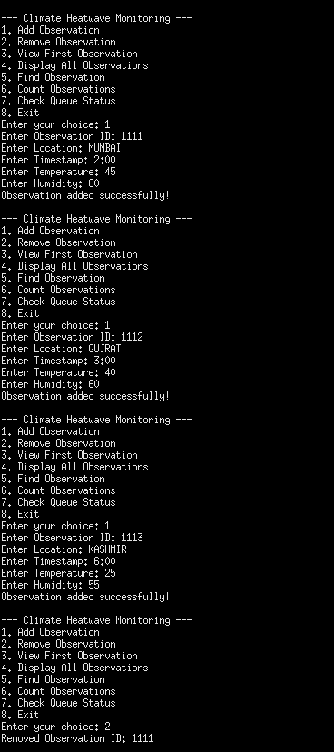
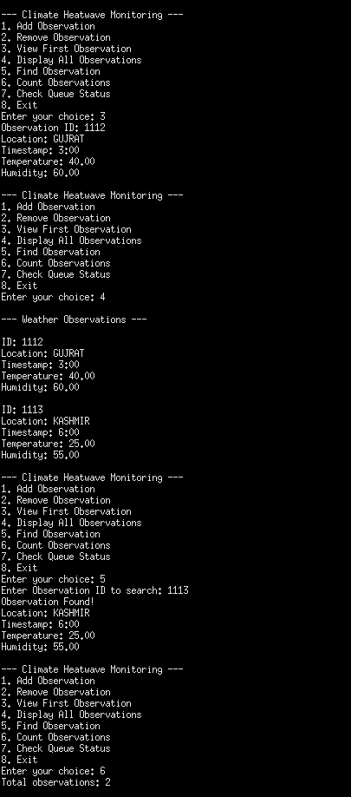
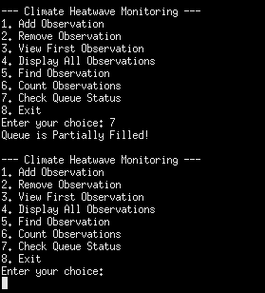
CLIMATE HEATWAVE MONITORING USING QUEUE
1. Queue and FIFO
Queue: A queue is a linear data structure where new weather records are added at the rear and existing records are removed from the front.
FIFO (First In, First Out): It is a rule in which the record entered first is the first record to be removed.

2. Demonstration of FIFO Processing
FIFO is illustrated by adding three weather observations to the queue and processing them in their insertion order.
Step 1: Enqueue Observations
Operation Queue (Front → Rear)
Enqueue 101 (Mumbai) 101
Enqueue 102 (Pune) 101 → 102
Enqueue 103 (Nagpur) 101 → 102 → 103
Step 2: Dequeue Observations
Operation Observation Removed Remaining Queue
Dequeue 101 (Mumbai) 102 → 103
Dequeue 102 (Pune) 103
Dequeue 103 (Nagpur) Empty

3. Algorithms
A. Enqueue (Add Observation)
STEP 1: If total == MAX, display "Queue is Full".
STEP 2: Otherwise, calculate rear = (rear + 1) % MAX.
STEP 3: Enter the observation ID, location, timestamp, temperature, and humidity.
STEP 4: Increase total by 1.
STEP 5: Stop.
B. Dequeue (Remove Observation)
STEP 1: If total == 0, display "Queue is Empty".
STEP 2: Otherwise, display the ID of the observation at the front.
STEP 3: Update front = (front + 1) % MAX.
STEP 4: Decrease total by 1.
STEP 5: Stop.
C. Peek (View First Observation)
STEP 1: If total == 0, display "Queue is Empty".
STEP 2: Otherwise, display the details of the observation at the front.
STEP 3: Stop.
D. Display Observations
STEP 1: If total == 0, display "Queue is Empty".
STEP 2: Otherwise, begin from the front position.
STEP 3: Print all stored observations one by one.
STEP 4: Move to the next position using (pos + 1) % MAX until all observations are displayed.
STEP 5: Stop.
E. Search Observation
STEP 1: Enter the observation ID to find.
STEP 2: Start checking from the front position.
STEP 3: Compare each stored ID with the entered ID.
STEP 4: If a match occurs, display the observation details.
STEP 5: If no match is found, display "Observation Not Found".
STEP 6: Stop.
F. Count Observations
STEP 1: Read the value of total.
STEP 2: Display the number of observations currently stored.
STEP 3: Stop.
G. Queue Status
STEP 1: If total == 0, display "Queue is Empty".
STEP 2: If total == MAX, display "Queue is Full".
STEP 3: Otherwise, display "Queue is Partially Filled".
STEP 4: Stop.

4. Time Complexity
Time complexity indicates how the execution time of an operation changes with the amount of input data. It is represented using Big O notation.
Operation Time Complexity Explanation
Enqueue O(1) Adds a record at the rear.
Dequeue O(1) Removes the front record.
Peek O(1) Reads the first record.
Display O(n) Prints every store observation.
Search O(n) May check all records.
Count O(1) Reads the total variable.
Queue Status O(1) Checks the number of stored records.

5. Space Complexity
Space complexity describes the amount of memory required during program execution.
Operation Auxiliary Space Complexity
Enqueue O(1)
Dequeue O(1)
Peek O(1)
Display O(1)
Search O(1)
Count O(1)
Queue Status O(1)

Overall Space Complexity: O(M)
Here, M represents the maximum queue capacity. The program uses an array that can hold a fixed number of weather observations. In this program, the maximum capacity is five.

